 Woodland View Junior School
Parent questionnaire FEEDBACK 2018 (35 responses)
Strongly agree
Agree
Neither
Disagree

Summary of Parent Questionnaire March 2018
.

1.
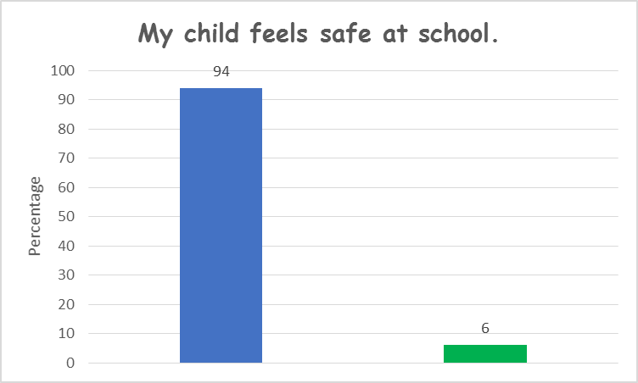
2.
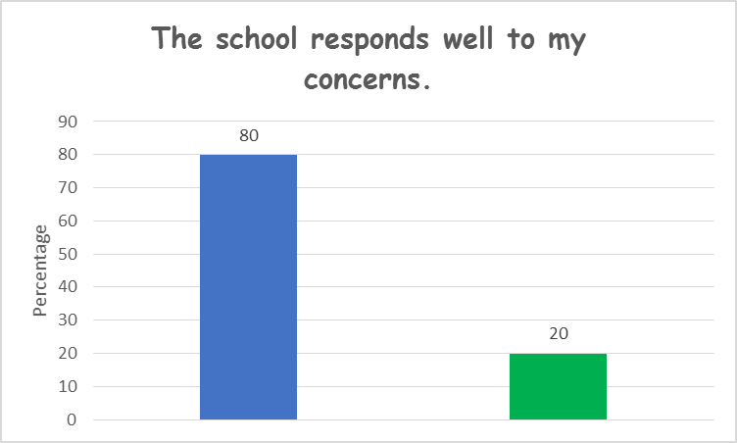
3.
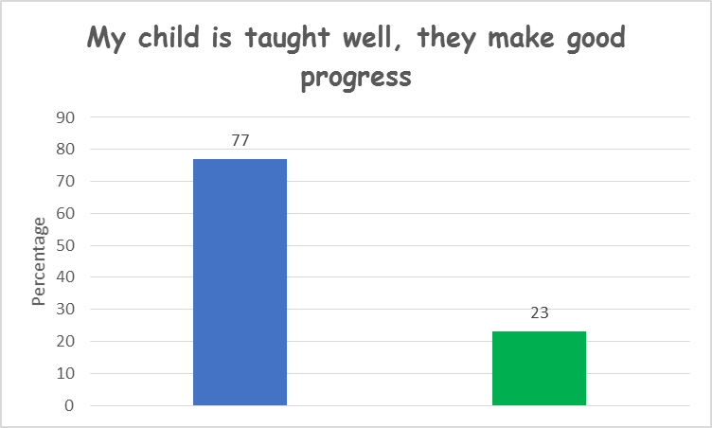

4.
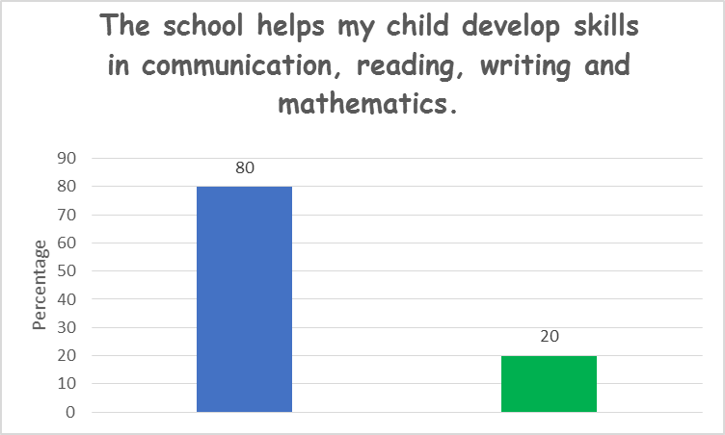
5.
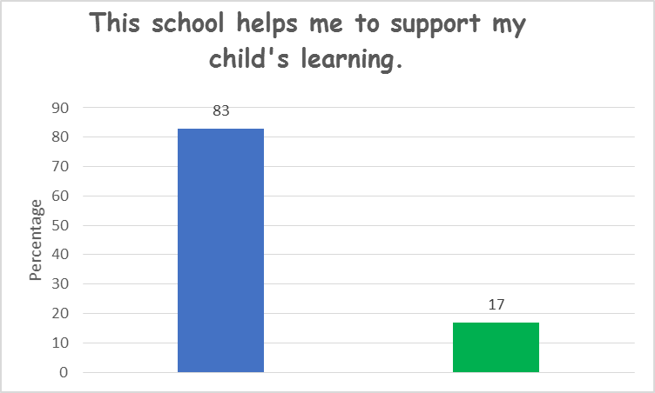
6.
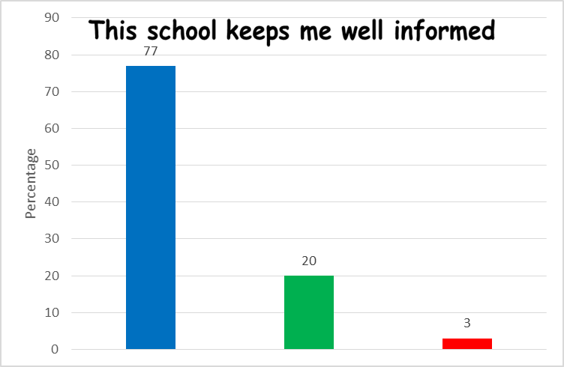

Comments:
My child is very happy at school!
Very happy with how quickly our concerns are dealt with.
Nice to have goals on the report.
My son has made good progress thanks to the support of the school.
Very happy with the report with both academic and non-academic topics covered.
Excellent communication via of text, email etc.
The school has always encouraged my son in everything he does.

Things we could do better or suggestions to think about:
Some letters have not been sent out or not enough notice has been given.
All letters will go on the website under correspondence.

Sometimes the toilets are dirty after lunch.
Caretaker’s hours are changing which will help with maintenance areas that need addressing.
Thank you for your continued support!

